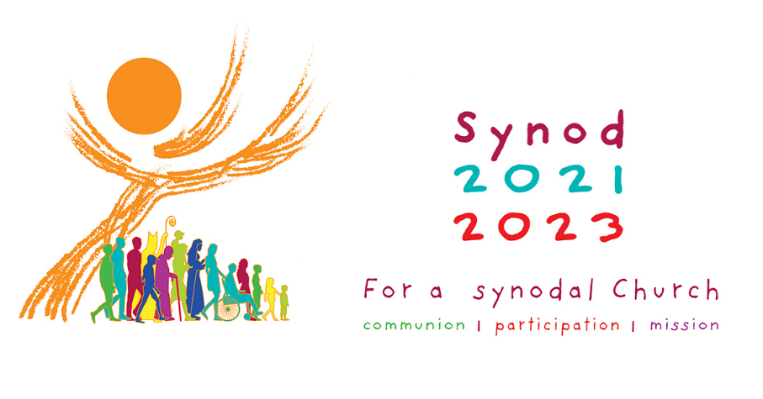

Synodal Process: Contemplative Dialogue
Notes for Parish Representatives
It may be unfeasible to enter into contemplative dialogue on all ten questions. Parishes may wish to organise a monthly meeting that focuses on two questions.

- Start with a Gathering Hymn; some suggestions:

Be still for the presence of the Lord,
Be not afraid,
Here I am, Lord,
One Bread, One Body,
The Lord is my Shepherd
Ubi Caritas,
Christ be our Light
Holy Spirit, Come to Us (Taizé)

- Reading of Scripture: Guided Meditation

- Prepare two questions for each meeting, although the Spirit may lead you to focus on one only.

- Sharing and Listening leading to new insights

- One member of the parish to gather responses

- Conclude with the Synod Prayer

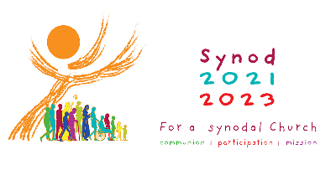

Synodal Process: Contemplative Dialogue 1
Gathering hymn
Guided Meditation followed by reflective silence
Suggestions:
Matthew 8:1-13
Mark 2:13-17

Focus Question 1
What is my dream for the Church so that it can become more outward looking, more missionary, especially towards those on the margins?
Possible Approaches
- Sharing of ‘dreams’
- Active listening of each other’s ‘dreams’
- New insight from shared wisdom
- Further responses from the dialogue

Focus Question 2
How is God speaking to us through voices we sometimes ignore? What space is there for the voice of minorities, especially people who experience poverty, marginalization, or social exclusion?
Possible Approaches
- Sharing of ‘dreams’
- Active listening of each other’s ‘dreams’
- New insight from shared wisdom
- Further responses from the dialogue

Conclude by a spontaneous prayer of thanksgiving to God for the sharing and the Synod Prayer.

Synodal Process: Contemplative Dialogue 2
Gathering hymn
Guided Meditation followed by reflective silence
Suggestions:
Proverbs 31: 8-9
John 8:1-11

Focus Question 3
What enables or hinders speaking up courageously, candidly, and responsibly in our local Church and in society?
Possible Approaches
- Sharing of ‘dreams’
- Active listening of each other’s ‘dreams’
- New insight from shared wisdom
- Further responses from the dialogue

Focus Question 4
How do prayer and liturgical celebrations actually inspire and guide our common life and mission in our community?
Possible Approaches
- Sharing of ‘dreams’
- Active listening of each other’s ‘dreams’
- New insight from shared wisdom
- Further responses from the dialogue

Conclude by a spontaneous prayer of thanksgiving to God for the sharing and the
Synod Prayer.

Synodal Process: Contemplative Dialogue 3
Gathering hymn
Guided Meditation followed by reflective silence
Suggestions:
Genesis 12:1-3
Matthew 28:18-20

Focus Question 5
What hinders the baptised from being active in mission? How does the community support its members who serve society in various ways (social and political involvement, scientific research, education, promoting social justice, protecting human rights, caring for the environment, etc.)?
Possible Approaches
- Sharing of ‘dreams’
- Active listening of each other’s ‘dreams’
- New insight from shared wisdom
- Further responses from the dialogue

Focus Question 6
How are divergences of vision, or conflicts and difficulties addressed? What particular issues in the Church and society do we need to pay more attention to? How does the Church dialogue with and learn from other sectors of society: the spheres of politics, economics, culture, civil society, and people who live in poverty?
Possible Approaches
- Sharing of ‘dreams’
- Active listening of each other’s ‘dreams’
- New insight from shared wisdom
- Further responses from the dialogue

Conclude by a spontaneous prayer of thanksgiving to God for the sharing and the Synod Prayer.

Synodal Process: Contemplative Dialogue 4
Gathering hymn
Guided Meditation followed by reflective silence
Suggestions:
Galatians 3:26-28
Romans 12:3-8

Focus Question 7
To what extent do we share our journey with members of other Christian traditions and denominations? What fruits have we drawn from walking together?
- Sharing of ‘dreams’
- Active listening of each other’s ‘dreams’
- New insight from shared wisdom
- Further responses from the dialogue

Focus Question 8
How is authority or governance exercised within our local Church? How are teamwork and co-responsibility put into practice? How are evaluations conducted and by whom? How are lay ministries and the responsibility of lay people promoted?
Possible Approaches
- Sharing of ‘dreams’
- Active listening of each other’s ‘dreams’
- New insight from shared wisdom
- Further responses from the dialogue

Conclude by a spontaneous prayer of thanksgiving to God for the sharing and the Synod Prayer.

Synodal Process: Contemplative Dialogue 5
Gathering hymn
Guided Meditation followed by reflective silence
Suggestions:
Matthew 5:13-16
Isaiah 55:8-13

Focus Question 9
Is there freedom to exercise our particular ministry in the Church and participate in this common work of discernment and decision-making?
Possible Approaches
- Sharing of ‘dreams’
- Active listening of each other’s ‘dreams’
- New insight from shared wisdom
- Further responses from the dialogue

Focus Question 10
What additional formation do I need to be a missionary disciple? What tools are necessary for the Church to be truly synodal, listening and journeying together?
Possible Approaches
- Sharing of ‘dreams’
- Active listening of each other’s ‘dreams’
- New insight from shared wisdom
- Further responses from the dialogue

Conclude by a spontaneous prayer of thanksgiving to God for the sharing and the Synod Prayer.

