517-2017: A Special Anniversary

One thousand five hundred years is an anniversary well worth celebrating – and Saturday, April 22nd saw the culmination of a period of co-operation between Gweithgor Padarn Sant 517-2017 (Working Party of the Parish of Aberystwyth), Y Cylch Catholig (a movement within the Catholig Church which gives support and encouragement in the Faith to Welsh-speaking Catholics) and the Church in Wales Parish of Llanbadarn Fawr, near Aberystwyth. This was the third of a series of events this year organised by the Gweithgor to celebrate Padarn – the Saint who brought Christianity to this area of Wales and under whose spiritual guidance Christianity flourished here.

The day – in Llanbadarn Fawr – began with a short morning “Retreat”, led by Fr. Allan Jones, C.R.I.C. who had travelled from his parish in Milton Keynes to join Welsh-speaking Catholics from all three Welsh dioceses for the day.

Following lunch at “Y Blac”, a number of retreatants visited an early Christian (and pre-Christian) burial site at Gogerddan where some important archaealogical discoveries have recently been made. The retreatants were guided around the site by Richard Suggett, of the Royal Commission on the Ancient and Historical Monuments of Wales who will also be leading the next “Saint Padarn” celebration event - an archaeological day of talks and a visit to the burial ground on May 20th.

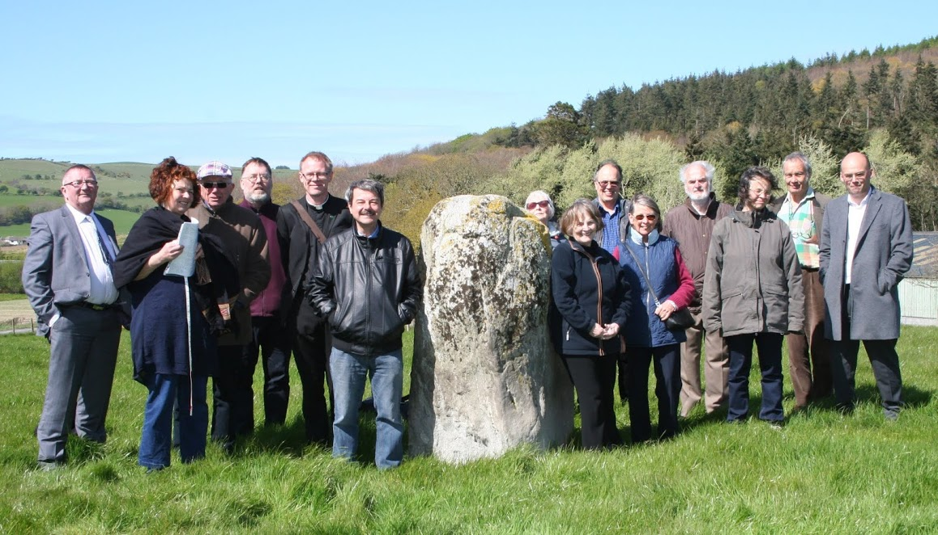
Some of the retreatants at the burial ground in Gogerddan

The day then concluded with a joyful and historic Mass in the church of Saint Padarn in Llanbadarn Fawr, near Aberystwyth. This would doubtless have been the first Roman Catholic Mass to be celebrated in that church since the Reformation – and the first ever to be celebrated there in the Welsh language as pre-Reformation Masses would have been in Latin.

The principal celebrant was Bishop Emeritus Edwin Regan who came from Blaenau Ffestiniog to lead the proceedings and he was ably assisted by Fr. Allan Jones C.R.I.C. and Fr. Adrian Edwards CSSp (who had travelled from Chester). Bishop Tom’s presence at this historic Catholic occasion was much appreciated – as was the presence of local dignatories Cllr. Brendan Somers and Mrs. Glynis Somers (Mayor and Mayoress of Aberystwyth) and Cllr. Martin Davies (Chairman of Llanbadarn Fawr Community Council) and Mrs. Delyth Davies. The choir, led by Jane Leggett and organist Peter Leggett, sang the Mass setting “Offeren Mair y Tapyr” by the late Alan Rees, former Abbot of Belmont and melodically led the psalm and hymns.

Simultaneous translation of the Readings, the Homily and the Bidding Prayers was provided by Rhys Huws for attendees who were not fluent in Welsh and bilingual copies of the Liturgy were also made available by means of the “Simple Prayer Book / Llyfr Gweddi Bach” (CTS 2015).

This occasion would not have been possible without the co-operation and goodwill of the Vicar of Llanbadarn, Rev. Canon Andrew Loat, and his parishioners and fellow-clergy who made us all very welcome and gave every possible assistance. We were delighted that they were able to join us for the Mass and that Fr. Tim Pearce of the Greek Orthodox Church in Lampeter was also able to attend.

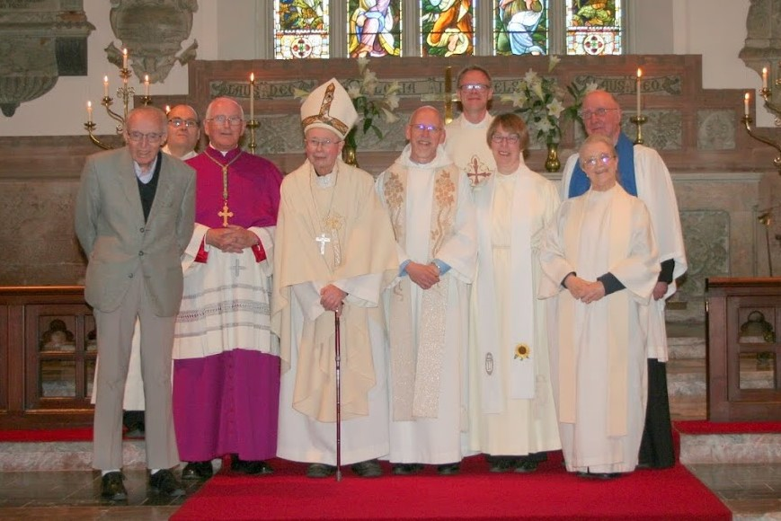
From left to right: Fr Adrian Edwards, Rev. Lyn Lewis Dafis, Bishop Tom Burns, Bishop Emeritus Edwin Regan,
Rev. Canon Andrew Loat, Fr Allan Jones, Rev. Heather Evans, Rev. Canon Enid Morgan, and Keith Jones, Honorary Reader.
(Photograph: William Owen Roberts)

We look forward to more opportunities for celebration of our joint Christian heritage as we continue to enjoy and appreciate our one thousand five hundredth anniversary. Events are open. All are welcome.

